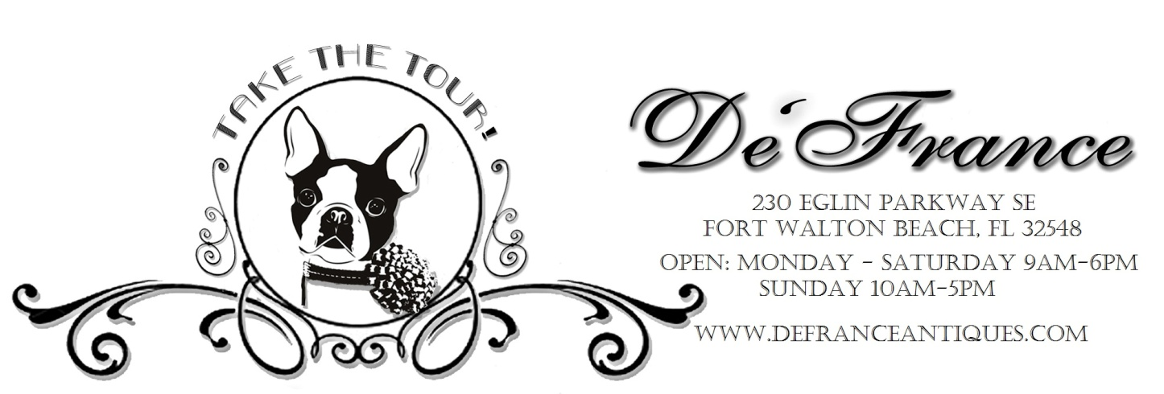

SPECIAL EVENT APPLICATION
Contact/Business Name : ___________________________________________________________________________
Telephone: _______________________________ Email: ________________________________________________
Electricity ($10 – limited availability): NO YES 8ft Tables ($5 each – limited availability): ________________
Booth Size:____________Total Fee: ____________ Form of Payment_______________ Date Paid _____________
Type items you will Sell/direct Sales Company:_________________________________________________________
_______________________________________________________________________________________________
Chili Cook-off & Saturday Market Feb 8, 2020. 9 am-2 pm..$15 for a 10x10..$30 for a 10x20
This market is designed for vendors to display their one-of-a-kind creations, re-purposed items, jewelry, clothing, furniture, art or to clear out everything.
French Street Market…..March 14, 2020…..9am-3pm…..$25 for a 10x10….$45 for a 10x20
Vendors will fill their spaces with a marvelous assortment of re-purposed, re-cycled and re-imagined treasures including furniture, antiques, jewelry, vintage décor and handmade items.
JunkFest….. April 13th, 2019….9am-3pm….$25 for a 10ftx10ft….$45 for a 10ftx20ft
The parking lot will be filled with everything and anything! This picker’s paradise of sorts is the perfect event to get rid of the items that have been lurking around for too long. Project pieces, overflow from booths, etc
2nd Saturday Market…..May 11th, 2019…..9 am-2 pm….$15.00 for a 10x10 and $30.00 for a 10x20
This market is designed for vendors to display their one-of-a-kind creations, re-purposed items, jewelry, clothing, furniture, art or to clear out everything.
2nd Saturday Market…..Sept 14th, 2019…..9 am-2 pm….$15.00 for a 10x10 and $30.00 for a 10x20
This market is designed for vendors to display their one-of-a-kind creations, re-purposed items, jewelry, clothing, furniture, art or to clear out everything.
JunkFest…. .October26th, 2019…9am-3pm….$25 for a 10ftx10ft….$45 for a 10ftx20ft
The parking lot will be filled with everything and anything! This picker’s paradise of sorts is the perfect event to get rid of the items that have been lurking around for too long. Project pieces, overflow from booths, etc
Christmas Market…..November 9th, 2019…..9am-3pm…..$25 for a 10ftx10ft….$45 for a 10ftx20ft
As one of our big events for the year, the Christmas Market is a fun event for all ages. Vendors will be set up with all kinds of holiday décor, gift items , vintage items, refinished furniture and so much more.
December Market…..December 7th, 2019…..9am-3pm…..$25 for a 10ftx10ft….$45 for a 10ftx20ft
As one of our big events for the year, this Market is a fun event for all ages. We have Christmas Open House inside and Vendors outside set up with all kinds of holiday décor, gift items , vintage items, refinished furniture and so much more. Choctaw StyleMarchers will be here with games and hopefully performing.

General Rules:

- Tables, chairs, tents etc. must be provided by the vendor unless rented from DeFrance. Tents are strongly recommended due to the direct sun exposure. Tents will need to be weighted down – it gets quite breezy during the day and you cannot spike the tents into the parking lot.
- Gates will open 1 ½ hours prior to the start time for vendors to set up their spaces. Someone will be outside directing the vendors to their assigned space.
- Gates will close 15 minutes prior to the start time for vendor vehicular traffic. If you arrive late, you will need to walk your items to your space.
- When you arrive, please pull into our east side parking lot, and drive around the back of the building in order to access the west side parking lot (where the event is occurring). This way we won’t have any traffic back-up occurring in the road.
- The aisles between the rows of booths are wide enough for two vehicles to pass through. Please make sure that when you pull up to your space that you leave enough room for someone else to drive around you. PLEASE DO NOT PULL INTO ANOTHER VENDOR'S SPOT TO UNLOAD YOUR ITEMS. PLEASE STAY IN THE AISLES.
- If you are planning on bringing a trailer to unload – please arrive early so you can unload it as soon as possible.
- We ask that you please unload everything into your space first and then move your vehicle right away into the designated parking lot. It can get congested so do not set up all of your tables and merchandise before moving your car. UNLOAD, MOVE CAR, SET UP BOOTH.
- Please be courteous and patient during this time as it can get very crowded and hectic with everyone trying to unload at the same time.
- All vendors are expected to stay set up for the entire event. If you have an emergency and need to leave prior to the end of the event you will need to come inside and notify us. You will not be able to bring your car into the vendor area to leave early; you will need to walk your items to your vehicle.
- Vendors are responsible for handling their own sales. We do have an ATM inside the store.
- If any customers purchase larger items from your booth – we will have a few carts available to help bring the items to their vehicles.
- Cancellation must be made at least 10 days in advance for a refund. If the market is canceled due to inclement weather, the fee will carry over to the next applicable market.
Mail or deliver completed form with payment to:
DeFrance Antiques at 230 Eglin Parkway S.E., Fort Walton Beach, Fl 32548
A confirmation will be returned to you by phone or email. You may email a completed form to defranceantiques@gmail.com and pay by phone with a credit card by calling (850) 314-7500 during store hours.

I, _____________________________________________ (print name) shall comply with all applicable federal, state, and local laws, rules and regulations.

Vendor Signature: _____________________________________ Date: ___________________________

